List of the more known toxic in door poisonous flowers and plants:

Plant Name | Toxicity Level | Plant Description | Symptoms of Poisoning
Primrose  (Cyclamin Persicum)   | Highly Toxic | The cyclamen is one of the most popular but poisonous flowers on the planet. It blooms red, pink and also in white in the colors. The five petals of a flower are bent backwards and sit on about 20 cm long stems. The flowering period is from August to April. The leaves are heart-shaped and drawn. | Symptoms include nausea and vomiting, sweating, and severe nausea with diarrhea. Furthermore, there are circulatory disorders and respiratory paralysis which occurs at lethal doses. It also acts externally on inflamed skin and on the eyes.
Pink Floyd, also known as Amaryllis  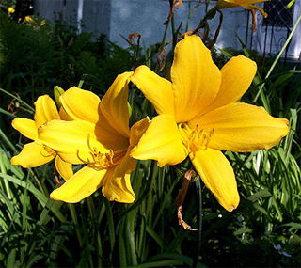  (Hippeastrum hybrids) | Toxic | The Amaryllis is a funnel-shaped, bulbous plant with nodding flowers. The color of the flower is red, pink and white. They stand on a stem that can reach 90 cm high. | Symptoms nausea and vomiting, excessive sweating, salivation, dizziness and diarrhea. It can also damage the kidneys and cause paralysis.
Weeping Fig    (Ficus Species) aka "Rubber Tree" | Toxic | This ficus species, like all others, excrete a milky white substance from its green, variegated leaves. | Vomiting and diarrhea will become present since paralysis and even death cannot be excluded even though this is one of the lesser poisonous plants for cats and dogs.
Snake Plant  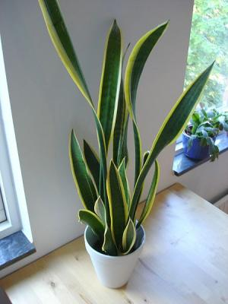  (Sansevieria) trifasciata aka "Mother-in-Law's Tongue" | Toxic | The leaves of the hemp sheets are sword-shaped, which form a rosette and have pale green spots. The plant grows up to three feet high. The flowers give off a strong scent and are yellowish. | The snake plant contains toxic components. The symptoms include nausea, vomiting, cramps and diarrhea.
Dumb Cane  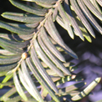 | Highly Toxic | The Dumb Cane is one of the most popular houseplants in the Americas. It has an oblong to oval shape, spanning 25 - 40 cm long. It has leaves that are dark green with white spots. The plant consists of a greenish husk even though it is rarely in bloom. It can reach a height of six feet. | Poisoning of animals is evident. Severe irritation of the mouth, irritation of the stomach, intestines and neck are seen. Animals have difficulty swallowing, difficulty breathing, associated with a loss of voice along with bloody diarrhea and possible death.
Dragon Tree  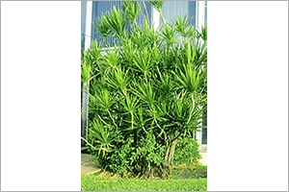  (Dracaena drago) | Toxic | 40 Dragon Tree species grow on Earth. Dracaeno drago is often found in the Canary Islands, where it can grow up to 30 feet high. In the Americas, it is kept as a houseplant. The leaves are evergreen, have inconspicuous flowers and orange colored fruits. | The Dragon Tree is one of the less poisonous plants for dogs and cats. In cats, diarrhea occurs after ingestion of the leaves.
Tulip  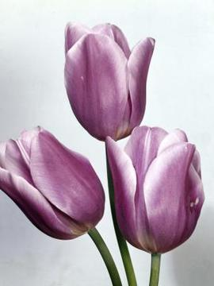 | Toxic | From April to May, the tulip drives their 4-8 cm long, bell-shaped flowers of the onion to bloom. According to the breed form, the flower color varies over white, yellow, orange, pink, red to blue and even black. The leaves are up to 30 cm long. | Poisoning starts with excessive salivation, vomiting, gastrointestinal pain and diarrhea.
Azalea  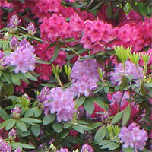  (Rhododendron Simsii) | Highly  Toxic | Azaleas bloom mostly red to pink. The flowers are bell-shaped or funnel-shaped and they are usually in corymbs. The leaves are oval and leathery. The plants grow bushy and often have a small trunk. | Vomiting, diarrhea, tremors, convulsions, weak pulse and slow breathing slow are the most common side effects. Animals also suffer from depression. When it comes to flowers poisonous to cats and dogs, this one is at the top of the list.
Oleander  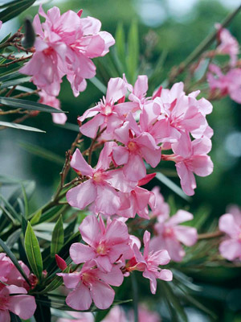 | Fatal | The Oleander grows as a shrub and sometimes as a small tree. Its pink or white flowers have five petals. They appear from July to September. The leathery leaves are usually three to a whorl. The plant grows up to 6 meters high. | Dilated pupils, drop in body temperature, cool legs and gastrointestinal discomfort with diarrhea. Death occurs, even in humans, by paralysis of the heart.
Chrysanthemum   | Toxic | This yellow flower heads in an umbrella-like panicle. They appear from July to September. The leaves are up to 25 cm long. The stems of the plant are edgy and it reaches a height of 60-130 cm. The plant smells very aromatic when crushed. | When it comes to flowers poisonous to dogs and cats, the Chrysanthemum targets house animals more than other animals. Tumbling, drowsiness, and blindness are associated with mucosal irritation, kidney and liver damage.

